ABHINAYA REDDY
Sr. Site Reliability Engineer
E-Mail: chittedi.abhinaya@gmail.com
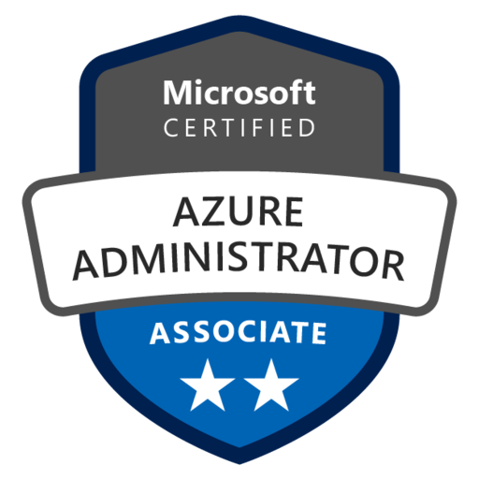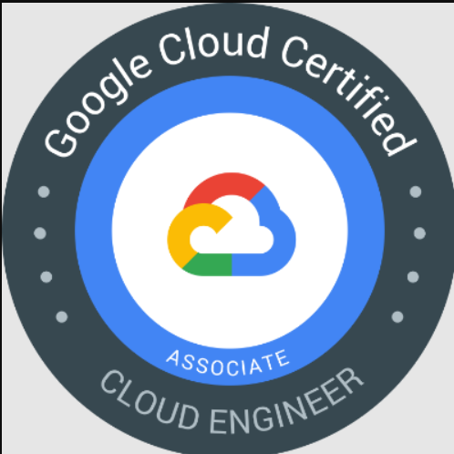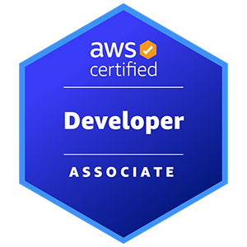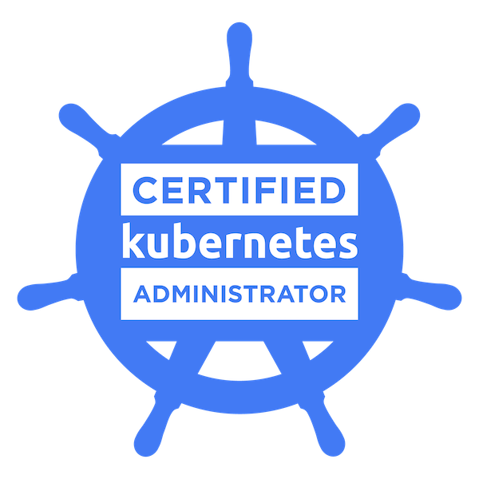
Contact: +1 (404) 532-9106
Linked in: Abhinaya | LinkedIn

Professional Summary:
Over 12+ years of experience in the IT industry, I have honed my expertise in a wide range of areas including Cloud Engineering, DevOps, Software Development, and System Administration. My background spans across private, public, and hybrid cloud platforms, with a strong focus on Google Cloud Platform (GCP), AWS Cloud and Microsoft Azure and Google Cloud Platform (GCP). I am skilled in Continuous Integration and Deployment (CI/CD), configuration management, and build/release automation. Throughout my career, I have leveraged tools such as Docker, Kubernetes, Terraform, Ansible, Chef, Jenkins, Git, and Maven to optimize development workflows and ensure robust, scalable infrastructure. Additionally, my experience as a Linux Systems Administrator has further strengthened my ability to manage complex IT environments and contribute to seamless operations.

- Experienced Site Reliability Engineer / DevOps Engineer with strong expertise in designing, implementing, and optimizing CI/CD pipelines using Jenkins, GitLab CI/CD, GitHub, and Maven, enabling reliable and automated production deployments.
- Extensive hands-on experience managing cloud-native applications across Google Cloud Platform (GCP), Azure, and hybrid environments, with strong focus on reliability, scalability, and performance.
- Proven expertise in building and managing GKE and Kubernetes clusters, including cluster provisioning, node pool management, autoscaling, ingress configuration, and production-grade workload orchestration.
- Strong background in Infrastructure as Code (Terraform and Ansible), automating provisioning of GCP resources such as VPCs, IAM roles, GKE clusters, Cloud SQL, and load balancers.
- Proficient in containerization using Docker and Helm, ensuring standardized and consistent microservices deployments across environments.
- Experienced in implementing SRE best practices including SLIs, SLOs, error budgets, proactive monitoring, and incident management, improving system stability and reducing MTTR.
- Hands-on expertise with monitoring and observability tools including Datadog, Prometheus, Grafana, ELK Stack, and GCP Cloud Monitoring, enabling proactive alerting and performance optimization.
- Strong understanding of GCP IAM, Workload Identity, RBAC, network security (VPC, Firewall Rules), and encryption standards, ensuring secure cloud infrastructure design.
- Experience working with SQL databases (MySQL, Oracle) and supporting performance tuning, query optimization, and cloud migration initiatives.
- Skilled in Python scripting and automation to reduce operational toil and improve deployment reliability across distributed systems.
- Proven ability to design secure, cost-effective, and compliant cloud architectures while maintaining operational efficiency.
- Strong problem-solving skills focused on continuous improvement of cloud infrastructure, security, and data management.
- Leadership experience mentoring teams, fostering a collaborative, growth-oriented environment.
- Driving culture change by collaborating closely with engineering teams to implement modern DevOps practices.
- Expert in GitOps methodologies, enabling seamless deployment workflows for engineering teams.
- Skilled in designing and delivering scalable, high-performance internal developer platforms.
- Proficient in improving DevOps tooling, software installation, and delivery pipelines for continuous enhancement.
- Track record of tuning infrastructure performance to enhance scalability, reliability, and cost-efficiency across cloud environments.
- Hands-on experience with Azure policies, Sentinel, and Defender for Cloud to ensure security, monitoring, and compliance.
- Expertise implementing Azure Identity solutions (Entra ID) and role-based access control (RBAC) for secure user and application management.
- Strong background managing Azure Kubernetes Service (AKS) infrastructure for scalable containerized applications.
- Experienced in applying Terraform for IaC to enable consistent, repeatable cloud resource provisioning.
- Skilled in designing Azure DevOps build and release pipelines for Kubernetes and serverless application deployments.
- Knowledgeable in container security best practices to secure containerized applications and infrastructure.
- Proficient in automating end-to-end build and release pipelines with Helm charts and integrating ServiceNow gates for governance.
- Applied security across the SDLC using tools such as SonarQube, Nexus IQ, Checkmarx, Snyk, Aqua, and Rapid7 (SAST, DAST, IAST).
- Extensive experience with AWS Cloud services including EC2, S3, EBS, ELB, CloudWatch, Elastic IP, RDS, SNS, SQS, Glacier, IAM, VPC, CloudFormation, and Route53, including security group management.
- Skilled in provisioning IaaS and PaaS solutions on AWS, Azure, and GCP using Agile, Scrum, and Waterfall methodologies, with solid Software Configuration Management (SCM) knowledge.
- Deployed and managed containerized applications on OpenShift Container Platform ensuring scalability, high availability, and resource efficiency.
- Conducted Azure security audits, remediating vulnerabilities using Azure Security Center recommendations.
- Developed Python-based automation scripts for log analysis and integration with Prometheus and Grafana APIs for system monitoring.
- Extensive experience in automating and optimizing GitLab CI/CD pipelines, streamlining software deployment and improving automation.
- Hands-on expertise in Infrastructure as Code (IaC), utilizing Terraform and Ansible for provisioning cloud infrastructure and automating configuration management.
- Proficient in building scalable cloud platforms from scratch using AWS, Azure, and Kubernetes, ensuring high availability, security, and performance.
- Expertise in troubleshooting Linux and networking issues, ensuring efficient resolution of system-level problems.
- Skilled in developing automation scripts using Shell and Python to automate routine tasks and improve system efficiency.
- Excellent written and verbal communication skills, strong organizational skills, and a hard-working team player.

Certifications:
- Certified Azure Administrator Associate.
- Certified AWS Developer Associate.
- Certified Kubernetes Administrator.

Technical Skills:
Cloud Platforms | Microsoft Azure, Aws Cloud, Google Cloud Platform
GCP Services | GKE, Cloud storage, VPC, Big Query, IAM, Artifact registry
AWS Services | RDS, EC2, VPC, IAM, Lambda Function, Cloud Formation, EBS, S3, ELB, Auto Scaling, Cloud Trial, SQS, SNS, SWF, Cloud Watch, WAF, ECR, EKS.
Azure Services | App Services, Key vault, function app, Blob storage, Azure Active Directory (Azure AD), Service Bus, Azure Container Registry (ACR) and Azure Kubernetes service (AKS), Azure SQL, Azure Cosmos DB.
CI/CD | Jenkins, Azure DevOps Pipelines , GitLab.
Version Control Tools | GIT, Bit Bucket.
Configuration & Automation Tools | Ansible, Maven, Terraform, Puppet, Chef
Container Platforms | Docker, Kubernetes, Red Hat Open Shift.
Monitoring Tools | Nagios, Splunk, Prometheus, Grafana, Datadog, New Relic.
Artifactory | Jfrog and Nexus
Web Servers | Apache Tomcat, WebSphere, Nginx
Documentation | Confluence
Operating Systems | Microsoft Windows XP/ 2000, Linux, UNIX.
Tracking Tools | Jira, ServiceNow, Azure Board.
Code Scanning | Sonar Qube, Jfrog X ray, ECR Inspector
Databases | RDS, Cosmos DB, My SQL, Aurora DB, Mongo DB.
Logging | Cloud Watch, Cloud Trail, Azure App Insights, Azure Monitor, ELK, Fluent
Languages | Python, Shell scripting, Golang.

PROJECT EXPERIENCE:
Client | UPS – New Jersey, NJ | April 2025 to Present
Role | Sr. Site Reliability Engineer
Responsibilities | - Designed and maintained secure, scalable CI/CD pipelines using Jenkins and Terraform, enabling automated deployments across development, staging, and production environments in Google Cloud Platform (GCP).  - Built and managed GKE clusters (private & VPC-native) using Terraform, including node pools, IAM service accounts, Workload Identity, autoscaling (HPA), and secure ingress configurations.  - Implemented Blue-Green and rolling deployment strategies for GKE workloads, ensuring zero-downtime releases and automated rollback capabilities.  - Developed Infrastructure as Code (IaC) using Terraform (GCP provider) to provision VPCs, subnets, Cloud NAT, IAM policies, GKE clusters, and Artifact Registry, ensuring repeatable and secure infrastructure builds.  - Managed and optimized GCP infrastructure focusing on high availability, regional failover, network security (VPC, Firewall rules), and cost optimization strategies.  - Integrated DevSecOps practices into CI/CD workflows, embedding container image scanning, policy validation, and security checks within Jenkins pipelines to strengthen production security posture.  - Implemented enterprise-grade monitoring using Datadog, Application Insights, Prometheus, and GCP Cloud Monitoring, enabling proactive alerting, dashboarding, and reduced MTTR.  - Defined and monitored SLIs/SLOs for mission-critical services, improving reliability and reducing production incidents through SRE best practices.  - Worked with SQL databases (MySQL/Oracle) and supported performance troubleshooting, query optimization, and database migration activities to cloud environments.  - Supported and monitored Elasticsearch clusters for log indexing and search performance optimization in distributed environments.  - Designed disaster recovery strategies using multi-zone GKE deployments and automated failover mechanisms to ensure business continuity.  - Built self-healing Kubernetes infrastructure leveraging autoscaling, health probes, pod disruption budgets, and automated remediation workflows.  - Collaborated closely with engineering teams to enhance release reliability, automate operational processes, and stabilize distributed production systems.
Environment | Terraform, Ansible, Docker, Kubernetes (GKE, AKS), Helm, OpenShift, Jenkins, Git, GitLab, GitHub, Azure DevOps (YAML Pipelines), Google Cloud Platform (GKE, VPC, IAM, Cloud NAT, Cloud Monitoring), Azure (Virtual Machines, Load Balancers, VPN Gateways),

Client | Siemens – Atlanta, GA. | Jul 2023 to April 2025
Role | Sr. Site Reliability Engineer
Responsibilities | - Designed and implemented real-time streaming architectures using Apache Kafka on Kubernetes (GKE/OpenShift), enabling low-latency ingestion and event-driven processing for distributed cloud-native systems.  - Architected and deployed RESTful APIs on GKE using containerized microservices, ensuring secure integration between cloud-native workloads and enterprise systems.  - Led automation of CI/CD pipelines using Jenkins and GitLab, enabling zero-downtime deployments for Kubernetes workloads across development and production environments.  - Implemented GitOps workflows using ArgoCD, establishing Git as the single source of truth for infrastructure and Kubernetes-based application deployments.  - Designed reusable Jenkins and GitLab pipeline templates with parallel execution, dependency scanning, and security validations to improve build reliability and code quality.  - Built and managed GKE clusters using Terraform, provisioning VPC-native networking, IAM roles, node pools, autoscaling, and secure ingress configurations.  - Developed Infrastructure as Code (IaC) using Terraform (GCP provider) to provision networking (VPC, Subnets, Firewall Rules), GKE clusters, service accounts, and Artifact Registry.  - Automated multi-environment provisioning using Terraform modules to deploy resources across GCP and hybrid cloud architectures, ensuring environment consistency and governance.  - Strengthened enterprise security posture by configuring GCP IAM policies, Workload Identity, Kubernetes RBAC, and encryption standards, ensuring compliance with enterprise security requirements.  - Optimized GCP networking using VPC design, Cloud Load Balancers, Cloud DNS, and secure ingress controllers, ensuring high availability and fault tolerance.  - Implemented centralized observability using Datadog, Prometheus, Grafana, ELK Stack, and GCP Cloud Monitoring, enabling proactive alerting, SLI/SLO tracking, and performance optimization.  - Established secure container registry practices using Artifact Registry, implementing image scanning, version control, and rollback strategies.  - Implemented secure Git merge workflows with approval gates, vulnerability scanning, and policy enforcement to strengthen CI/CD governance.  - Automated operational workflows using Python and Ansible, reducing manual toil and improving infrastructure reliability.  - Worked with SQL databases (MySQL/Oracle) and supported database performance tuning, query optimization, and cloud migration initiatives.  - Led production incident troubleshooting, root cause analysis (RCA), and reliability improvement initiatives following SRE best practices.
Environment | Google Cloud Platform (GKE, VPC, Cloud Load Balancing, Cloud SQL, IAM, Cloud DNS, Artifact Registry, Cloud Monitoring, Cloud Logging), OpenShift, Kubernetes, Docker, Terraform (GCP Provider), Ansible, Jenkins, GitLab CI/CD, GitHub Actions, ArgoCD

Client | SMBC - Jersey City, NJ. | May 2022 to Jun 2023
Role | Sr. Site Reliability Engineer
Responsibilities | - Designed and deployed multi-cluster GKE and OpenShift environments to support highly available, scalable microservices architectures across multiple regions and zones in GCP.  - Automated end-to-end infrastructure provisioning using Terraform (GCP provider) and Ansible, accelerating GKE cluster builds and ensuring consistent, policy-driven cloud environments.  - Implemented secure networking architectures using GCP VPC, private clusters, firewall rules, Cloud NAT, and Cloud Load Balancing, enabling secure connectivity between Kubernetes workloads and enterprise systems.  - Enforced platform security by configuring GCP IAM roles, Workload Identity, Kubernetes RBAC policies, and encryption standards, ensuring secure hybrid-cloud authentication and least-privilege access.  - Implemented Istio service mesh to enhance traffic routing, mTLS security, observability, and fine-grained service-to-service communication across microservices.  - Built centralized logging and observability solutions using ELK Stack, Datadog, Prometheus, Grafana, and GCP Cloud Monitoring, enabling proactive alerting, SLI/SLO tracking, and performance optimization.  - Optimized resource utilization and cost by implementing Kubernetes autoscaling (HPA), cluster autoscaler, and right-sizing strategies, reducing idle infrastructure costs and improving workload efficiency.  - Deployed and managed stateful applications using Persistent Volumes and Cloud SQL, ensuring durability, backup reliability, and disaster resilience.  - Automated backup and disaster recovery strategies using Velero and multi-zone GKE configurations, strengthening business continuity and compliance posture.  - Designed and implemented GitOps workflows using ArgoCD and Helm, ensuring version-controlled, reproducible Kubernetes deployments across clusters.  - Integrated Jenkins and GitLab CI/CD pipelines with GKE, enabling automated build, test, security scan, and deployment processes using reusable pipeline templates.  - Developed Python automation scripts to provision and manage GCP resources such as GKE, IAM, Cloud Storage, and Load Balancers, reducing manual operational effort.  - Orchestrated Blue-Green and rolling deployments on GKE, ensuring zero-downtime releases and automated rollback mechanisms.  - Integrated enterprise identity systems with GCP IAM and Kubernetes RBAC, enabling secure identity governance and access control across hybrid environments.  - Implemented CI/CD security scanning, code quality checks (SonarQube), and artifact management (Artifact Registry), strengthening DevSecOps and supply chain security.  - Led production incident troubleshooting, root cause analysis (RCA), and reliability improvements following SRE best practices, improving system stability and reducing MTTR.
Environment | Google Cloud Platform (GKE, VPC, Cloud Load Balancing, Cloud SQL, Cloud Storage, Cloud DNS, IAM, Artifact Registry, Cloud Monitoring, Cloud Logging), OpenShift, Kubernetes, Docker, Terraform (GCP Provider), Ansible, Jenkins, GitLab CI/CD, ArgoCD, Helm, Istio Service Mesh, Prometheus, Grafana

Client | State of NE – Lincoln, NE | Feb 2021 to Apr 2022
Role | DevOps Engineer
Responsibilities | - Designed and implemented infrastructure automation using Ansible and Terraform, standardizing environment provisioning and configuration management across GCP-based Kubernetes environments.  - Developed reusable automation modules to provision GKE clusters, VPC networking, IAM roles, and Cloud SQL instances, converting legacy scripts into policy-driven Infrastructure as Code solutions.  - Implemented a GitOps-based deployment model using ArgoCD and Helm for microservices on Kubernetes, enabling version-controlled, auditable, and automated deployments across environments.  - Integrated Prometheus and Grafana with GKE workloads for real-time monitoring, health visualization, SLI/SLO tracking, and deployment observability.  - Enforced security and compliance in CI/CD pipelines by integrating Open Policy Agent (OPA), container image scanning, and vulnerability assessments within Jenkins workflows.  - Built CI/CD pipelines using Jenkins integrated with Git and Maven, enabling automated builds, code quality checks (SonarQube), Docker image creation, and secure deployment to GKE.  - Optimized container builds using Docker and Maven plugins, improving microservices performance and deployment consistency.  - Deployed and managed GKE clusters supporting Dev, Test, and Production environments, implementing autoscaling, node pool management, and secure ingress configurations.  - Automated GCP infrastructure provisioning using Terraform (GCP provider) to manage VPCs, firewall rules, service accounts, IAM bindings, and Cloud Storage lifecycle policies.  - Implemented high availability and backup strategies using multi-zone GKE clusters and Cloud SQL automated backups, ensuring business continuity and resilience.  - Worked with SQL and MongoDB databases, supporting performance tuning, replication, and data consistency for distributed applications.  - Configured and maintained monitoring solutions including Prometheus, Grafana, Datadog, and GCP Cloud Monitoring, automating alerting using Python scripts.  - Installed and maintained Linux-based application servers, performing performance tuning, resource optimization, and troubleshooting in production environments.  - Managed enterprise identity and access security using GCP IAM and Azure Entra ID integrations, implementing RBAC policies, conditional access controls, and automated user lifecycle governance.
Environment | Google Cloud Platform (GKE, VPC, Cloud SQL, Cloud Storage, IAM, Cloud Monitoring, Cloud Logging), Azure Entra ID, Kubernetes, Docker, Terraform, Ansible, Jenkins, Git, Maven, SonarQube, Prometheus, Grafana, Datadog, OPA (Open Policy Agent), Kyverno, MongoDB, SQL (MySQL, Oracle), Python, Linux.

Client | Ally Financial, Charlotte, NC. | Nov 2019 to Jan 2021
Role | DevOps Engineer
Responsibilities | - Designed and implemented containerized solutions using Docker, creating custom images and managing application lifecycle across environments.  - Built and deployed infrastructure using Terraform (IaC) and AWS CloudFormation, provisioning EC2, ELB, VPC, and auto-scaling infrastructure.  - Configured secure AWS networking using IAM roles, Security Groups, Route 53, Public/Private subnets, and VPC design best practices.  - Designed and deployed scalable cloud-native applications using AWS services (EC2, S3, RDS, DynamoDB, SNS, SQS, ELK) with focus on high availability and fault tolerance.  - Implemented container orchestration using Kubernetes, managing deployments, services, load balancing, and multi-environment (Dev/Test/Prod) clusters.  - Automated configuration management using Ansible (YAML-based playbooks) to standardize provisioning across private and cloud environments.  - Built CI/CD pipelines using Jenkins integrated with Git, enabling automated builds and deployments across non-production and production environments.  - Managed Docker container lifecycle including image creation, tagging, snapshotting, registry management, and container troubleshooting.  - Supported microservices architecture by integrating Docker, Kubernetes, Terraform, and Jenkins into a cohesive DevOps workflow.  - Enhanced automation and deployment efficiency through scripting using Shell and PowerShell.
Environment | AWS (EC2, ELB, VPC, Route 53, S3, RDS, DynamoDB, SNS, SQS), Terraform, CloudFormation, Docker, Kubernetes, Jenkins, Ansible, Git, Maven, YAML, PowerShell.

Client | PeopleNet – Hopkins, MN. | Jun 2018 to Oct 2019
Role | Build Release Engineer
Responsibilities | - Designed and implemented CI/CD and release management processes to standardize and streamline software delivery across environments.  - Automated end-to-end release pipelines enabling zero-touch deployments using Jenkins, SVN, Nexus, and Nolio.  - Built and maintained highly available infrastructure on AWS, leveraging EC2, EBS, S3, CloudFormation, IAM, and Elastic Load Balancing (ELB).  - Implemented AWS IAM roles, policies, and security groups to enforce secure access and network segmentation.  - Automated configuration management using Chef, Puppet, and shell scripting to ensure environment consistency.  - Containerized MySQL and application workloads using Docker, and implemented monitoring using Nagios.  - Designed and deployed Java Enterprise applications on Apache Web Server and JBoss Application Server.  - Built high-availability Docker infrastructure behind Application Load Balancers and HAProxy.  - Developed and maintained automated build frameworks using Jenkins, Bamboo, Maven, and Ant, including modification of POM.xml files and dependency management.  - Managed source control systems (Git and Subversion), including repository administration and custom hook development using Python and Perl.  - Deployed snapshot and release artifacts to Nexus Repository Manager, enabling artifact sharing across teams.  - Implemented centralized monitoring and performance management across servers, databases, and applications using Tivoli Monitoring, Nagios, and Splunk.  - Wrote automation scripts using Python, Shell, and Perl to support build, deployment, and orchestration workflows.  - Documented AWS architectural best practices and contributed to scalable, cloud-native system design.
Environment | AWS (EC2, EBS, S3, IAM, ELB, CloudFormation), Docker, Jenkins, Bamboo, Nexus, Git, SVN, Maven, Ant, Chef, Puppet, Python, Shell Scripting, Perl, Splunk, Nagios, Red Hat Kickstart.

Client | Aveva, Hyderabad, India. | Jul 2013 to Sep 2017
Role | Linux Administrator
Responsibilities | - Installed, configured, maintained, and supported RedHat, SUSE, Ubuntu, CentOS, Solaris, and HP-UX servers across Production and Development environments.  - Performed OS patching, upgrades, and package management using RPM and YUM, ensuring system stability and security compliance.  - Administered file systems, implemented disk quotas, and managed storage solutions across SAN/NAS environments.  - Configured and managed clustered servers in SUSE Linux for high availability.  - Implemented backup and recovery procedures; monitored and resolved failed backup jobs to ensure data integrity.  - Installed and configured Apache, Tomcat, and JBOSS application servers to support enterprise applications.  - Provided 24x7 production support, troubleshooting OS, network, and application-level issues across multi-platform environments.  - Configured and secured systems using SSH, firewall rules, and TCP/IP networking principles.  - Managed source control systems (Git, SVN), including repository creation, branch management, hooks configuration, and access control.  - Installed and administered Jenkins and Bamboo CI tools to support automated builds and deployment processes.  - Automated build processes using Ant and Maven, supporting Agile/SCRUM-based development teams.  - Provisioned and replicated build servers using virtualization and configuration management tools (VMware, VirtualBox, Packer, Vagrant, Chef).  - Collaborated with development teams to configure environments, troubleshoot deployment issues, and streamline release workflows.
Environment | Linux (RHEL, CentOS, Ubuntu, SUSE), UNIX, Solaris, HP-UX, TCP/IP, NIS, DHCP, FTP, Telnet, SSH, Nagios, Kickstart, VMware vSphere, VMware ESXi, VirtualBox, Logical Volume Manager (LVM), SAN/NAS, Disk Quotas, RPM, YUM, Apache, Tomcat, Firewalls.

